|  |  |
| --- | --- |
| **Project Name** | Smart Waste Management System For Metropolitan Cities |
| **Team ID** | PNT2022TMID20896 |

Technology Stack and Architecture

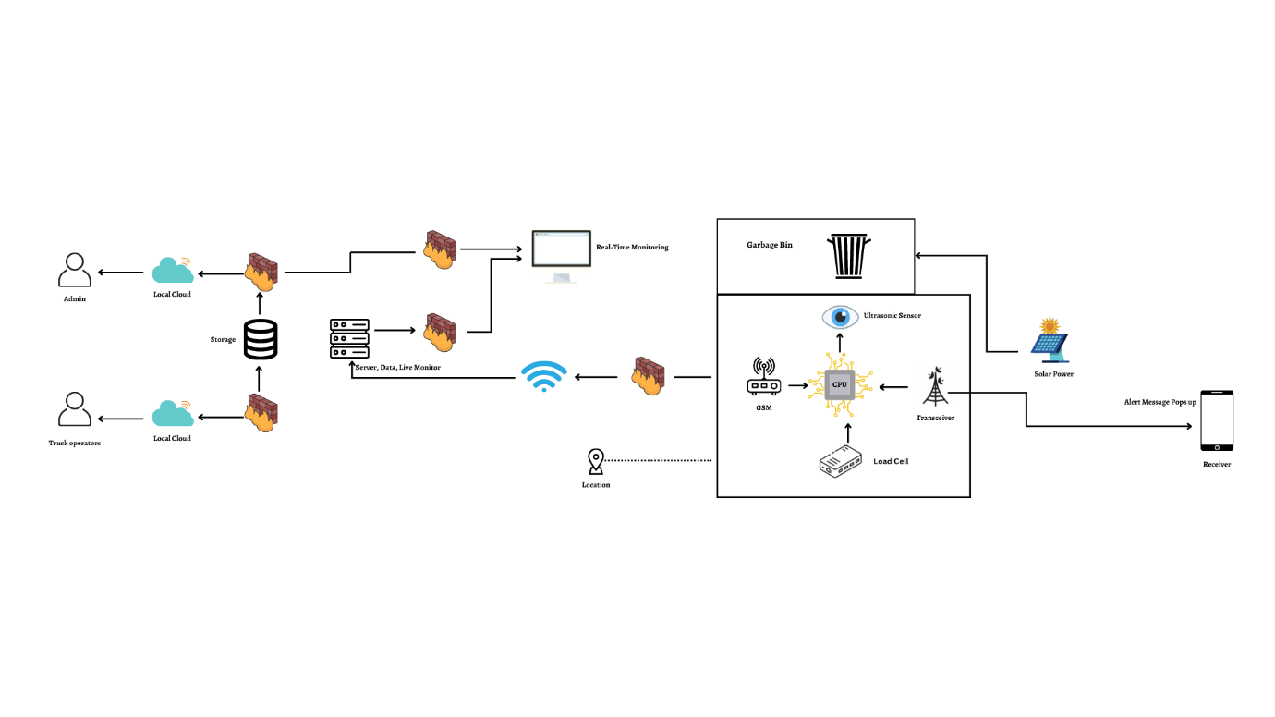

Table-1 : Components & Technologies:

|  |  |  |  |
| --- | --- | --- | --- |
| **S.No.** | **Component** | **Description** | **Technology** |
| 1. | User Interface | Web Portal | HTML, CSS, NodeRed, Javascript. |
| 2. | Application  Logic-1 | To calculate the level of trash through the ultrasonic sensor and activate alert message with python script. | Ulrasonic Sensor/ Python |
| 3. | Application Logic-2 | To calculate the weight of garbage and activate alert message with python script. | Load cell/ Python |
| 4. | Application Logic -3 | Get the location of trash. | GSM/GPS |
| 5. | Cloud Database | Database service though cloud | IBM DB2, IBM Cloudant |
| 6. | File Storage | Storing of files | Github, Local File system |
| 7. | External API-1 | Setting up of hosting services. | Firebase |
| 8. | Ultrasonic Sensor | To throw alert message when garbage is full | Distance recognition model |
| 9. | Infrastructure | Deployment of application and web portal | Localhost, Web Portal |

Table-2: Application Characteristics:

|  |  |  |  |
| --- | --- | --- | --- |
| **S.No.** | **Characteristics** | **Description** | **Technology** |
| 1. | Open-Source Frameworks | NodeRed, Python, IBM Simulator. | IoT |
| 2. | Security Implementations | Raspberry Pi is connected to the internet and  is used to broadcast live data, further  security measures are recommended and use  the UFW (uncomplicated Firewall). | IoT |
| 3. | Scalable Architecture | Raspberry Pi: Specifications  Soc: rspi ZERO W  CPU:32-bit computer with a 1GHz AR Mv6  RAM: 512MB Networking: Wi-Fi  Bluetooth: Bluetooth 5.0, Bluetooth Low  Energy (BLE).  Storage: MicroSD  GPIO: 40-pin GPIO header, populated  Ports: micro HDMI 2.0, 3.5mm analogue audio- video jack, 2x USB 2.0, 2x USB 3.0, Ethernet Dimensions: 88mm x 58mm x 19.5mm, 46g | IoT |
| 4. | Availability | These smart bins use to send an alert message when the bin gets full. | IoT |
| 5. | Performance | Number of request: RPI manages to execute 129- 139 read requests per second.  Use of Cache:512mb Use of CDN’s:Real time | IoT |